ITC327W – Unit 1 & 2 Portfolio
Software Requirements Specification (SRS)
Phehello Secondary School – Online Enrolment System
Group members:
224131387 KI. Makhoali
221000537 PIJ. Lebusa
220049867 LR. Mahlatsi
222018199 M. Lepitla
224074632 MM. Motaung
220042034 DT. Adegbola

Module: ITC327W

Table of Contents
Part A – Initial SRS (Activities 1.1 & 1.3)
- 1. Project Title 2. Project Description 3. Problem Statement 4. Purpose 5. Project Scope
- 6. Definitions 7. Stakeholders & Users 8. Current Process 9. Product Perspective 10. Main Product Functions
- Requirements (FR / NFR / SR / IR) Prioritised Requirements Table
Part B – Appendices & Project Setup Evidence (Activities 1.2 & 1.3)
- Appendices A–E & Project Setup Evidence
Part C – Unit 2: Feasibility, Risk & Refined Scope (Activities 2.1–2.3)
- Feasibility Study · Project Risk Register · Refined Scope · Requirements Change Log · Group Reflection

PART A: INITIAL SRS

1. Project Title
Phehello Secondary Online Enrolment System

2. Project Description
This project is being developed as part of ITC327W Work-Integrated Learning for Phehello Secondary School, a public secondary school whose enrolment process is currently entirely manual and paper-based. The group is developing a prototype online enrolment system consisting of a Flutter mobile application for parents/guardians, an ASP.NET web application for school staff (a Financial Clerk and an Administrator), and a shared Supabase backend. The system will allow parents to apply for enrolment, upload required documents and proof of payment, and track application status online, while staff verify payments and review applications digitally instead of on paper. The stakeholder is the Principal of Phehello Secondary School, who confirmed the current process, problems, and requirements during a stakeholder needs-assessment interview conducted via Microsoft Teams on 24 August 2026 (see Appendix B). The stakeholder was not part of the group's original plans; it was identified while searching for a real stakeholder within the local community, when the group walked past Phehello Secondary and decided to approach it directly rather than continue searching elsewhere. The group chose to proceed with this stakeholder because enrolment is a problem every member has personally experienced — each member's own parents had to make repeated trips back and forth to complete their own high school enrolment — making it a genuine, relatable problem worth investigating.

3. Problem Statement
Phehello Secondary School currently uses a manual, paper-based process to enrol new learners. Parents collect, complete, and physically deliver enrolment forms and supporting documents (ID, clinic card, and other documents specified on the school's enrolment form) to the school in person, and must pay an enrolment fee to the financial clerk before the application is finalised. This results in time-consuming, often repeated trips to the school - particularly when documentation is incomplete or incorrect - slow manual processing split across a financial clerk and an administrator, and no way for parents to track application or payment status. The problem affects parents/guardians (especially young or working parents, for whom repeat trips are costly in time and money) and school staff, since the administrator and financial clerk each spend significant one-on-one time per application, limiting their capacity for other duties. An improved solution is needed to let parents apply, upload documents and proof of payment, and track status online, while letting the financial clerk verify payments and the administrator review, approve/reject, and communicate with parents digitally.

4. Purpose
The purpose of the prototype is to improve how Phehello Secondary School receives, verifies, and manages learner enrolment applications, by allowing parents to apply and upload documents remotely and allowing school staff to review and process applications digitally rather than on paper.

5. Project Scope
Scope element | Group response
Project aim | To develop an integrated prototype that allows parents to apply for their child's enrolment at Phehello Secondary online, including uploading required supporting documents, and allows school administration staff to review, verify, and process applications digitally.
Main objectives | Allow parents to complete and submit an online enrolment application.  Allow parents to upload required documents.  Allow parents to track application status.  Allow admin staff to view, verify and approve/reject applications.  Provide a secure record of applications and documents
Deliverables | Flutter mobile application prototype (parent-facing)  ASP.NET web admin application prototype (school-facing)  Supabase backend/database and document storage  Project documentation
Acceptance criteria | Parents can complete and submit a complete enrolment application through the mobile application.  Parents can upload the required supporting documents.  Submitted applications appear in the ASP.NET web administration application.  Authorised admin staff can review an application and update its status.  Updated application status is visible to the parent through the mobile application.  Application information and uploaded documents are stored securely in Supabase.
Exclusions | Integration with Department of Education systems (e.g. SA-SAMS)  Online fee/payment processing  Online medical consultations  Province-wide deployment  Production use of real learner records  Advanced analytics beyond basic application information/status  Full school management functionality beyond enrolment
Constraints | Project must be completed within the academic project period.  Development limited to Flutter, ASP.NET and Supabase  Testing relies on sample/mock data.  Access to the school's actual infrastructure may limit on-site testing.  The school will not provide real learner/student personal information for the project
Assumptions | Principal and staff will be available for scheduled meetings.  School will provide a sample of its current enrolment form.  Target parents have access to a smartphone and basic connectivity

6. Definitions and Abbreviations
Term / Abbreviation | Meaning
SRS | Software Requirements Specification
Flutter | Framework used to develop the mobile application
ASP.NET | Framework used to develop the web application
Supabase | Shared online backend and database
WIL | Work-Integrated Learning

7. Stakeholders and User Groups
Stakeholder / user | Role in the proposed system | Responsibilities/Interest
Maleshoane Gweneth Adegbola | Principal, Phehello Secondary School - project sponsor and primary point of contact | Provides overall stakeholder direction, confirms the school’s needs and approves important project findings and decisions.
Zukiswa Khondlo | Secretary to the Principal and delegated stakeholder representative responsible for working with the project group and participating in requirements elicitation. | Provided information about the current enrolment process, participated in the requirements interview, confirmed the findings on behalf of the school.
Parent/Guardian | Primary user of the mobile enrolment application | Registers, completes enrolment applications, uploads required documents and proof of payment, and tracks application status.
Administrator | School staff member user | Reviews submitted proof of payment and verifies payment information.
Financial Clerk | Staff member user | Reviews applications, verifies documents, approves/rejects applications, communicates with parents and manages the enrolment process.
Stakeholder Delegation: The Principal, Maleshoane Gweneth Adegbola, is the official stakeholder and project sponsor for the project. During the initial scoping meeting on 20 August 2026, the Principal confirmed her willingness to act as the group’s official stakeholder. Due to her work commitments and limited availability, she delegated Zukiswa Khondlo, her Secretary to work with the group as her stakeholder representative. Zukiswa therefore participated in the formal requirements interview and provided information about the school enrolment process and requirements and confirmed the interview findings on behalf of Phehello Secondary School on the 24 August 2026.

Stakeholder Analysis Table
Stakeholder | Role | Interest | Influence | Main need
Maleshoane Gweneth Adegbola | Official Stakeholder Project Sponsor | High | High | Successful digital enrolment and alignment with the school needs
Zukiswa Khondlo | Delegated Stakeholder Representative | High | Medium | Accurate requirements and an enrolment process that reflects the school’s current procedures
Administrator | System user | High | High | Review, verify, approve/reject and manage applications
Financial Clerk | System user | High | Medium | Verify submitted proof of payments and payment information.
Parents/Guardians | End user | High | Medium | Apply remotely and track status

8. Current Process
Parents/guardians who wish to enrol a child at Phehello Secondary must obtain a paper enrolment form, complete it by hand, and submit it in person at the school together with the required supporting documents. According to the enrolment form provided by Phehello Secondary School, the required supporting documents for an accepted learner are a copy of immunisation records, a copy of the birth certificate, a progress report from previous school and a transfer letter from the previous school. Before enrolment is finalised, a fee is paid to the financial clerk, who issues a payment slip. The administrator then reviews the application and verifies the submitted documentation.

People involved
- Parents/guardians: complete and submit the enrolment form, supporting documents, and payment.
- Financial Clerk: receives the enrolment fee and issues a payment slip and verifies the proof of payment submitted with the application.
- Administrator: reviews the application, checks the forms are completed correctly, verifies the documentation and manages the application process.

Information used
- Enrolment/registration form (paper-based)
- Copy of immunisation records
- Copy of birth certificate
- Progress report from the previous school
- Transfer letter from the previous school
- Proof of payment (payment slip issued by the financial clerk)

Current tools or methods
- Paper enrolment forms and physical document submission, payment slips and manual filing ; no digital system currently used for enrolment.

Problems experienced
- Parents /Guardians: incorrect or incomplete documentation may require parents to travel back to the school to correct their applications, resulting in additional time and transport costs.
- Staff workload: The financial Clerk and Administrator spend significant time handling applications and assisting parents individually, reducing the time available for their other responsibilities.
- Paper-based records: Paper forms and supporting documents can be lost, damaged, or incompletely filled in, making applications difficult to manage and retrieve.
- No status tracking: Parents cannot easily check the progress of their enrolment or payment status without contacting or returning to the school.

Current Process Diagram
Parent/Guardian obtains blank enrolment form | → | Parent/Guardian  completes form by hand | → | Parent/Guardian gathers supporting documents | → | Parent/Guardian travels to school and submits the application and documents | → | Parent/Guardian pays enrolment fee to financial clerk and Clerk issues payment slip | → | Admin staff checks & files application

9. Product Perspective
The proposed prototype will consist of two connected applications supported by a shared Supabase backend. The Flutter mobile application will be used by parents or guardians to register, complete and submit learner enrolment applications, upload required supporting documents and proof of payment, and track application status. The ASP.NET web application will be used by authorised school staff, including the Financial Clerk and Administrator, to verify payment information, review supporting documents, process applications, and update application statuses. Both applications will use the same Supabase backend so that information submitted through the mobile application can be accessed by authorised staff through the web application and status updates can be reflected in the parent’s application view.

10. Main Product Functions
Component | Main functions
Flutter mobile application | Register/sign in, complete and submit enrolment application, upload documents and proof of payment, view application/payment status.
ASP.NET web application – Financial Clerk | Sign in, view submitted proof of payment, verify payment information proof of payment against school records and update payment verification status.
ASP.NET web application - Administrator | Sign in, view submitted applications, review and verify documents, approve/reject/request corrections, leave notes, message parents about incorrect documents, send deadline reminders, view a running application count, generate confirmation letters.
Supabase backend | Store parent and learner information, enrolment applications, uploaded documents, proof of payment, application status, each learner's unique student number and provide shared data access for the mobile and web applications.

11. Requirements
Functional Requirements (FR)
The following functional requirements define what the proposed online enrolment system must do. The requirements are based on the current enrolment process and the findings confirmed during the formal stakeholder requirements interview on 24 August 2026.
ID | Requirement
FR1 | The parent must be able to register and sign in through the Flutter application.
FR2 | The parent must be able to complete and submit an enrolment application through the Flutter application.
FR3 | The parent must be able to upload the required supporting documents (copy of birth certificate, a progress report from the previous school, a copy of immunisation records and a transfer letter from the previous school) through the Flutter application.
FR4 | The parent must be able to upload proof of payment (payment slip) through the Flutter application.
FR5 | The parent must be able to view the status of a submitted application, including payment verification status, through the Flutter application.
FR6 | The Financial Clerk must be able to verify a parent's proof of payment against the school's payment records through the ASP.NET application.
FR7 | The Administrator must be able to view submitted applications through the ASP.NET application.
FR8 | The Administrator must be able to approve, reject, or request corrections on an application through the ASP.NET application.
FR9 | The Administrator must be able to leave notes on an application through the ASP.NET application.
FR10 | The Administrator must be able to message a parent about incorrect or missing documents through the ASP.NET application.
FR11 | The Administrator must be able to send reminders to parents about application deadlines.
FR12 | The system must be able to generate a confirmation letter (including the school logo, learner name, ID number, and student number) once an application is accepted.
FR13 | The Administrator must be able to view a running count of applications received through the ASP.NET application.
FR14 | The system must store submitted applications, documents, and proof of payment in Supabase.

Non-Functional Requirements (NFR)
ID | Requirement
NFR1 | Only authorised staff (Financial Clerk or Administrator, per their role) must be able to access the ASP.NET administration dashboard.
NFR2 | Uploaded documents and proof of payment must be stored securely and only accessible to authorised users.
NFR3 | The prototype must use test/mock data instead of real learner records.
NFR4 | Error messages shown to parents and staff must be clear and understandable.
NFR5 | The mobile interface must display correctly on a standard Android smartphone.
NFR6 | The system must enforce role-based access control. The Financial Clerk must only be able to access payment-related information and verify proof of payment. The administrator must be able to access applications and supporting documents and must be the only staff role authorised to approve , reject, or request corrections on an application.

System Requirements (SR)
ID | Requirement
SR1 | The mobile application must be developed using Flutter.
SR2 | The web application must be developed using ASP.NET.
SR3 | The shared backend must use Supabase.
SR4 | The source code must be stored in a GitHub repository.

Integration Requirements (IR)
ID | Requirement
IR1 | Applications and documents submitted through Flutter must be stored in Supabase.
IR2 | Applications stored in Supabase must be displayed in the ASP.NET application.
IR3 | Status updates made through ASP.NET must be reflected in the Flutter application.

Prioritised Requirements Table
ID | Requirement | Type | Priority | Related stakeholder need
FR1 | Register/sign in via Flutter | Functional | Must Have | Needed for any parent to use the mobile application
FR2 | Submit enrolment application via Flutter | Functional | Must Have | Reduce in-person form submission
FR3 | Upload required documents (ID, clinic card, etc.) via Flutter | Functional | Must Have | Reduce reliance on physical document submission and repeat trips for incorrect documentation
FR4 | Upload proof of payment via Flutter | Functional | Must Have | Fee must be paid before enrolment is finalised; financial clerk needs to verify it
FR5 | View application/payment status via Flutter | Functional | Must Have | Parents currently cannot check status without returning to the school
FR6 | Financial Clerk verifies payment via ASP.NET | Functional | Must Have | Matches the financial clerk's actual role in the current process
FR7 | Administrator views applications via ASP.NET | Functional | Must Have | Reduce manual filing/checking of paper forms
FR8 | Administrator approves/rejects/requests corrections via ASP.NET | Functional | Must Have | Speed up application processing
FR9 | Administrator leaves notes on an application | Functional | Should Have | Supports the administrator's existing review workflow
FR10 | Administrator messages parents about incorrect documents | Functional | Must Have | Directly addresses the #1 challenge raised: incorrect documentation causing repeat trips
FR11 | Administrator sends deadline reminders | Functional | Should Have | Requested during the stakeholder requirements interview to help manage the enrolment process
FR12 | System generates confirmation letters | Functional | Must Have | Explicitly requested -includes school logo, learner name, ID number, student number
FR13 | Administrator views running application count | Functional | Should Have | Explicitly requested reporting need
FR14 | Store applications & documents in Supabase | Functional | Must Have | Maintain a searchable digital record
NFR1 | Restrict admin dashboard to authorised staff | Non-functional | Must Have | Protect learner personal information
NFR2 | Secure document & payment storage | Non-functional | Must Have | Protect sensitive documents and payment proof
NFR3 | Use test data in prototype | Non-functional | Must Have | POPIA / data-privacy compliance
NFR6 | Separate Financial Clerk and Administrator permissions | Non-functional | Must Have | Matches the two distinct staff roles identified in the interview
SR1 | Mobile app built in Flutter | System | Must Have | Module requirement
SR2 | Web app built in ASP.NET | System | Must Have | Module requirement
SR3 | Shared backend in Supabase | System | Must Have | Module requirement
IR1 | Flutter submissions stored in Supabase | Integration | Must Have | Applications must reach staff without manual re-entry
IR2 | Supabase records shown in ASP.NET | Integration | Must Have | Staff need to see applications and payments as they arrive
IR3 | ASP.NET status updates reflected in Flutter | Integration | Should Have | Parents need up-to-date status
PART B : APPENDICES & PROJECT SETUP

Appendices
Appendix | Evidence | Status
Appendix A | Stakeholder interview questions | See Part B below
Appendix B | Stakeholder responses / meeting notes | Attached - full interview conducted 24 August 2026 (Microsoft Teams); see Interview Record and Minutes Summary below
Appendix C | Evidence of stakeholder engagement | Attached - stakeholder identity, WhatsApp/Teams scheduling evidence, and Meeting Charter & Minutes below
Appendix D | Stakeholder confirmation of findings | Attached - findings summary, confirmation table, and evidence below
Appendix E | Additional current-process evidence | Attached - see images below

Project Setup Evidence
Item | Evidence | Status
Microsoft Project schedule | Original .mpp file with 3 phases, tasks, dates, dependencies, milestones | Attached separately
GitHub repository | Working link, README, all members with access | Attached
Supabase project | Screenshot showing project exists | Attached
Project Progress Tracker | Completed ITC327W Excel workbook | Attached separately
Group Reflection | 300–400 words, completed in Excel workbook | Attached

APPENDIX A : STAKEHOLDER INTERVIEW QUESTIONS

About the current enrolment process
- Could you explain, in your own words, how the current enrolment process works from start to finish?
- Who is involved in the process, from the time a parent submits a form to the time enrolment is confirmed?

About the challenges you currently experience
- What difficulties do you or your administration staff experience with the current enrolment process?
- Which of these problems causes the greatest difficulty for you or your staff?

About whom would use a new system
- Who would use a mobile application to submit enrolment applications?
- Who at the school would use the web application to review and manage applications?

About required information and functionality
- What information about a learner and their application needs to be recorded and kept?
- What should parents be able to do using the mobile application (for example, submit an application, upload documents, or check status)?
- What would you like staff to be able to do through a web-based system (for example, approve, reject, or request corrections)?

About reporting and access
- What reports or summaries would help you manage enrolment (for example, number of applications received, pending, or approved)?
- Who should be allowed to view or update an application once it has been submitted?

About measuring success
- How will you know that a new proposed system has successfully addressed the challenges you face today?

APPENDIX B : INTERVIEW RESPONSE & MEETING NOTES

Phehello Secondary School – Online Enrolment System
Date of interview: 24 August 2026
Location / platform: Microsoft Teams
Stakeholder present: Zukiswa Khondlo - Secretary to the Principal, Phehello Secondary School
Group members present: KI. Makhoali , PIJ. Lebusa , LR Mahlatsi , M. Lepitla , MM. Motaung , DT. Adegbola

Interview Record
# | Question | Stakeholder response | Follow-up required? | Confirmed?
1 | 1.Could you explain, in your own words, how the current enrolment process works from start to finish? | Parents collect and fill in enrolment forms. Before the process is complete, a fee is paid to the financial clerk, who issues a payment slip as proof. Parents then submit the forms together with supporting documents (ID/birth certificate, clinic card, etc.). | No | Yes
2 | 2.Who is involved in the process, from the time a parent submits a form to the time enrolment is confirmed? | Three people: the parent, the financial clerk, and the administrator. | Yes- answered live | Yes
3 | (Follow-up) In your words, what would you say is the role of the financial clerk and the administrator in the application process? | The financial clerk receives the payment and issues the payment slip. The administrator reviews the application, ensures the forms are filled in properly, and checks that the documentation is correct. | No | Yes
4 | 3.What difficulties do you or your administration staff experience with the current enrolment process? | For young and working parents: documentation is sometimes incorrect, requiring them to travel back and forth - difficult given distance, and some travel on foot. For staff: long queues and a high amount of human interaction limits their time for other duties. | No | Yes
5 | 4.Which of these problems causes the greatest difficulty for you or your staff? | For parents: the back-and-forth travel. For admin staff: the amount of individual human interaction, since it takes focus away from other responsibilities. | No | Yes
6 | 5. Who would use a mobile application to submit enrolment applications? | Young parents and working parents. | No | Yes
7 | 6. Who at the school would use the web application to review and manage applications? | The financial clerk and the administrator. The clerk checks in the system whether payment has been made, comparing proof of payment to the school's records. The administrator approves or rejects applications and leaves a comment/message for parents if a document is incorrect. | No | Yes
8 | 7. What information about a learner and their application needs to be recorded and kept? | To be confirmed against the actual enrolment form, which the school is going to send the group so they can see exactly what questions are asked and what information/documents are required. | Yes - awaiting the enrolment form from the school | Yes
9 | (Follow-up) So in it, does it also list the required documents? | Yes | No | Yes
10 | 8. What should parents be able to do using the mobile application (for example, submit an application, upload documents, or check status)? | Fill in the required information, attach the correct documents, and check the status of their application. | No | Yes
11 | 9. What would you like staff to be able to do through a web-based system (for example, approve, reject, or request corrections)? | Approve or reject applications; check that uploaded documents are correct and leave notes for parents where necessary; retrieve proof of payment to check against school records; and alert applicants to how much time is left to apply and when applications close. | No | Yes
12 | 10. What reports or summaries would help you manage enrolment (for example, number of applications received, pending, or approved)? | A running count/spreadsheet of applications received, so the school can track progress against numbers. Once accepted, a confirmation letter should be produced including the learner's name and ID/student number. | No | Yes
13 | (Follow-up) So you guys have student numbers at high school? | Yes - every student has a special/unique student number attached to them. | No | Yes
14 | 11. Who should be allowed to view or update an application once it has been submitted? | The applicant (parent) can log in and out and view their status. The administration can oversee the whole process. | Yes - answered live | Yes
15 | (Follow-up) Who is the administrator that is going to be in charge - secretary, chief secretary, or someone else? | Schools have more than one administrator with different roles; the person responsible for the school system specifically will be the one in charge. | No | Yes
16 | (Follow-up) How do we make sure a confirmation letter is official? | The school will provide its logo for use on the letter. The learner's unique student number is also used as a check - if someone arrives claiming to be enrolled without the correct number, or using someone else's number, this can be verified (or flagged as unsuccessful) against the school's system. | No | Yes
17 | 12. How will you know that a new proposed system has successfully addressed the challenges you face today? | Shorter queues and less one-on-one human interaction with administration, freeing staff to focus on their own work, since interacting with people individually takes up a lot of time. | No | Yes

Stakeholder Meeting Charter & Minutes( Appendix B)
Phehello Secondary School - Online Enrolment System

Meeting Details
Field | Details
Date | 24 August 2026
Time | 11:00
Platform | Microsoft Teams
Stakeholder | Zukiswa Khondlo - Secretary to the Principal, Phehello Secondary School (the Principal, Maleshoane Gweneth Adegbola, was not present for this session but assigned us her secretary as her delegated representative)
Meeting type | Full formal stakeholder needs-assessment interview (Activity 1.2) - all 12 interview questions from Appendix A were covered

Attendees
Name | Role
Zukiswa Khondlo | Secretary to the Principal - answered on the school's behalf
K.I. Makhoali | Group member
P.I.J. Lebusa | Group member
M. Lepitla | Group member
MM. Motaung | Group member
DT. Adegbola | Group member
LR. Mahlatsi | Group member

Meeting Objectives
- Work through the full 12-question stakeholder needs-assessment interview (Appendix A)
- Understand the current enrolment process, its challenges, and who is involved
- Establish who would use the proposed mobile and web systems, and how
- Confirm required learner/application information and system functionality
- Capture evidence that the formal interview took place

Minutes Summary
The full interview record (all 12 questions, responses, and follow-up questions) is captured in Appendix B. Key points discussed:
- Current process: forms + supporting documents + a payment to the financial clerk before submission.
- Three roles involved: parent, financial clerk, administrator.
- Main challenges: incorrect documentation causing repeat trips for parents, and high staff time spent on one-on-one interactions.
- A mobile app would be used mainly by young/working parents; a web system by the financial clerk and administrator.
- Required learner information will be confirmed once the school sends the group its actual enrolment form.
- Reporting needs include an application count and confirmation letters carrying the school logo and each learner's student number.
Success would be measured by shorter queues and reduced one-on-one staff time

Outcomes
All 12 questions covered? Yes.
Findings confirmed by the stakeholder’s delegated representative? Yes- Zukiswa Khondlo confirmed the findings on behalf of Phehello Secondary School.

Interview Evidence

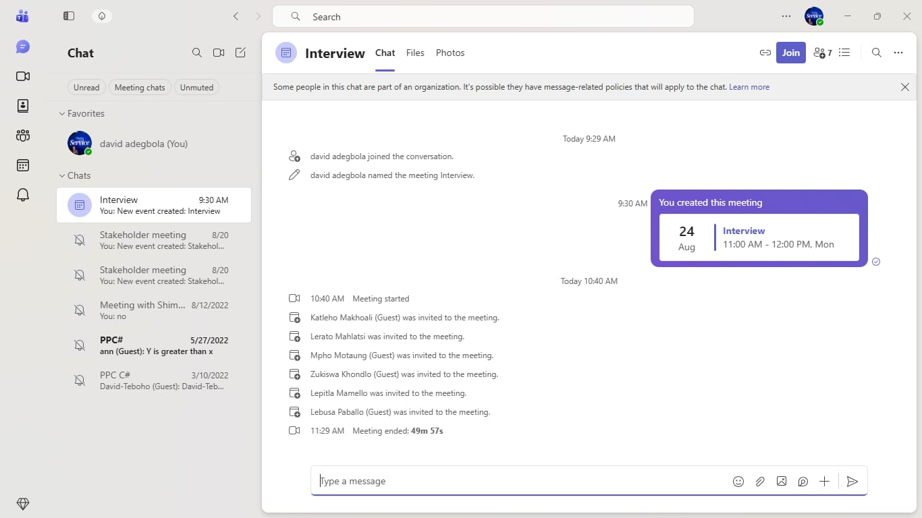
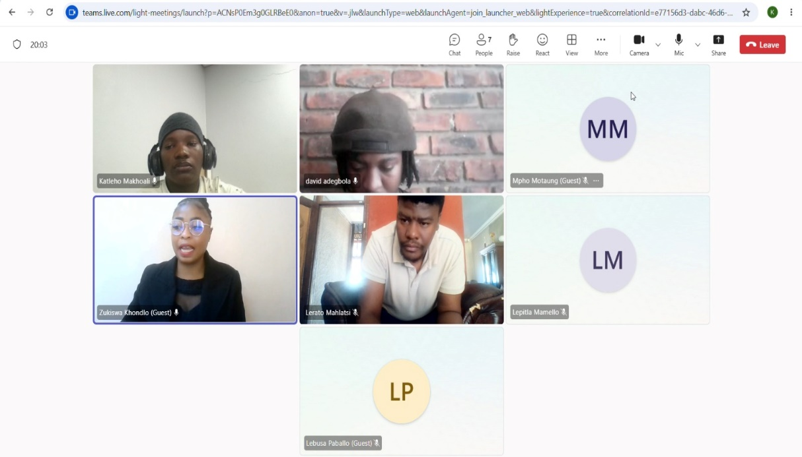

APPENDIX C : EVIDENCE OF STAKEHOLDER ENGAGEMENT

The following items support that the stakeholder identified in the Stakeholder Profile is a real, verifiable person and that the group has engaged with them directly.
Item | Purpose | Status
Screenshot: stakeholder identity | Confirms the principal is a real, identifiable person (e.g. official school Facebook page) | Attached
Meeting confirmation | Calendar invite, message, or email confirming a scheduled meeting date/time | Attached
Meeting evidence | Photo or attendance record from the actual meeting | Attached

1. Stakeholder Identity
 | 

3. Meeting Confirmation

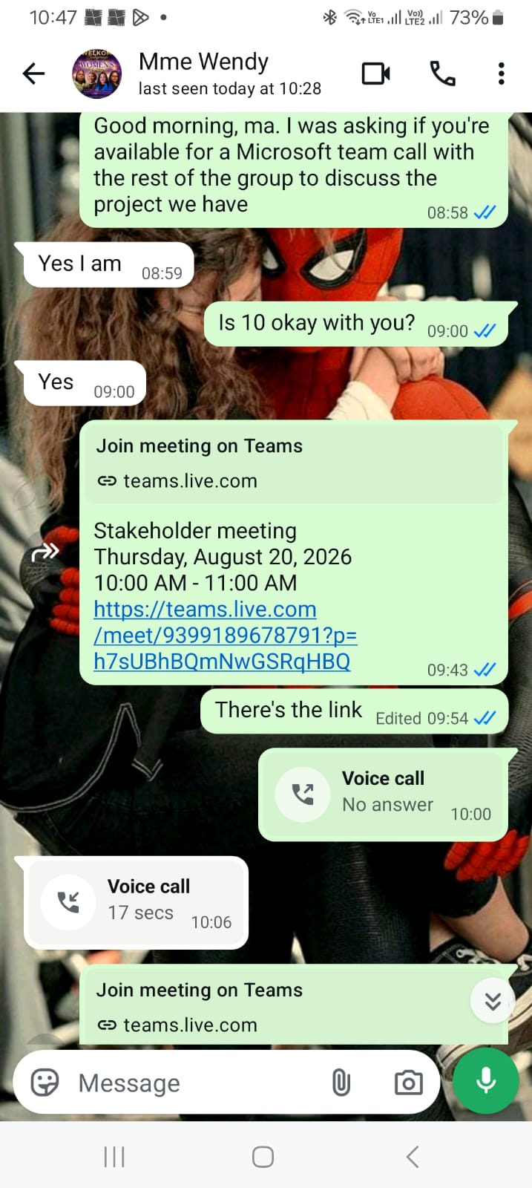

4. Meeting Evidence
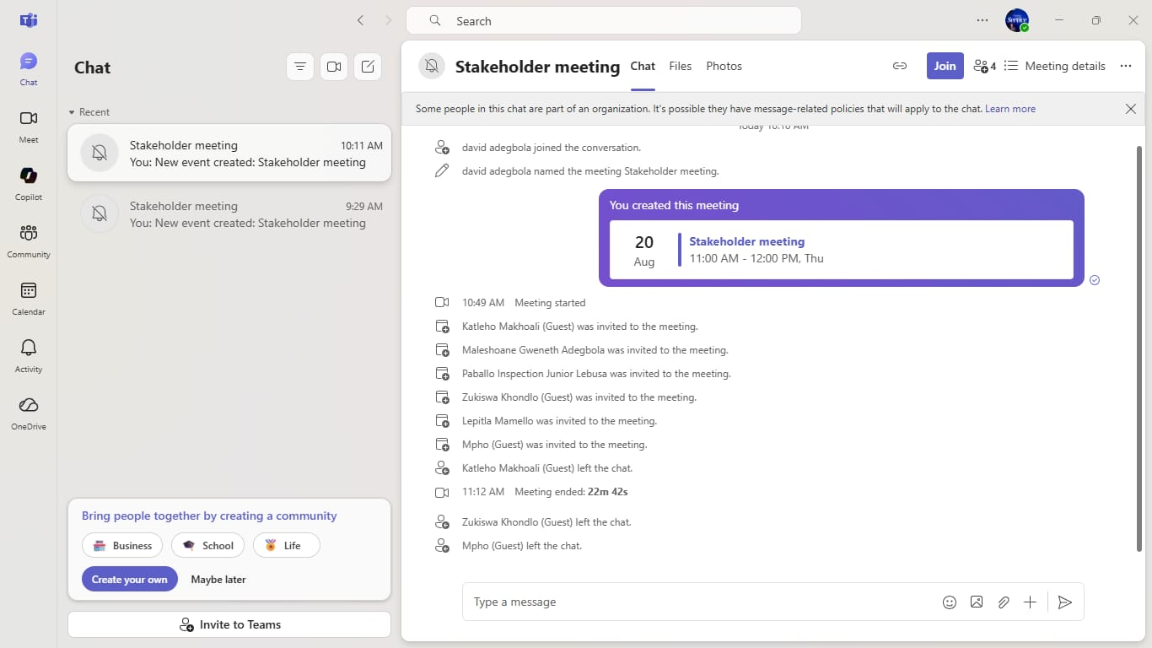

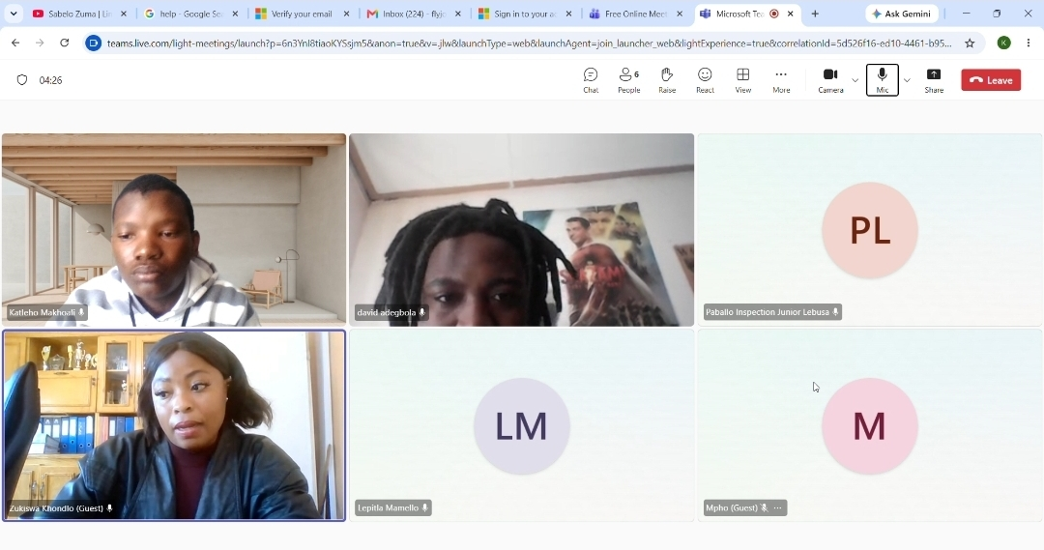

Stakeholder Meeting Charter & Minutes( Appendix C)
Phehello Secondary School - Online Enrolment System

Meeting Details
Field | Details
Date | 20 August 2026
Time | 11:00
Platform | Microsoft Teams
Stakeholder | Maleshoane Gweneth Adegbola - Principal, Phehello Secondary School (present for the first part of the meeting; call continued with Zukiswa Khondlo, Secretary to the Principal, after the principal had to leave)
Meeting type | First introductory / scoping meeting (not the full formal interview)

Attendees
Name | Role
Maleshoane Gweneth Adegbola | Principal, Phehello Secondary School - Stakeholder (present for introductions, project explanation, and confirmation of stakeholder role; left partway through)
Zukiswa Khondlo | Secretary to the Principal - continued the meeting on the principal's behalf after she left
K.I. Makhoali | Group member
P.I.J. Lebusa | Group member
M. Lepitla | Group member
MM. Motaung | Group member
DT. Adegbola | Group member

Meeting Objectives
- Formally introduce the group and explain the Work-Integrated Learning project in full
- Confirm the stakeholder's willingness to participate as the group's official stakeholder
- Gain a first-pass understanding of the current enrolment process at Phehello Secondary
- Agree on a date for the full, formal stakeholder needs-assessment interview
- Capture evidence that this meeting took place

Planned Agenda
Time | Item | Notes
5 min | Introductions | Each group member states name and role
10 min | Explain the project | What the project is, why, what a prototype means here
2 min | Confirm stakeholder role | Ask directly for agreement to act as the group's stakeholder
15 min | Light current-process discussion | 2–3 open questions only - not the full interview
2 min | Schedule formal interview | Propose a date/time for the full 9-question interview
2 min | Close & thank

Minutes
To be completed live during the meeting.
Topic | Discussion / Response | Decision / Action
Introductions | Group members introduced themselves and their roles. The principal introduced Zukiswa Khondlo, her secretary. | -
Project explanation | Group explained the Work-Integrated Learning project, the purpose of the prototype, and what would be expected of the stakeholder. | Principal confirmed her understanding of the project.
Confirm stakeholder role | Group asked the principal directly whether she was willing to act as the group's official stakeholder for the project. | Agreed - Yes, confirmed by the principal.
Principal's availability | Principal explained she needed to leave for another commitment shortly after confirming her role. | Handed the remainder of the meeting to Zukiswa Khondlo, her secretary.
Current process discussion (with secretary) | Zukiswa gave a brief, informal overview of how enrolment forms are currently received and filed at the school. | Treated as preliminary only and subsequently verified and expanded upon during the formal Activity 1.2 interview with Zukiswa Khondlo, the principal’s delegated representative.
Schedule formal interview | Group discussed timing for the full stakeholder needs-assessment interview. | Completed - the formal interview was held on 24 August 2026 via Microsoft Teams (see Appendix B).
Close & thank | Group thanked Zukiswa for her time and confirmed next steps. | -

Outcomes

Stakeholder agreement confirmed?
Yes — the principal confirmed directly, before she had to leave the call, that she is willing to act as the group's official stakeholder for this project.

Key points learned about the current process
Preliminary, secretary-level notes were gathered from Zukiswa Khondlo after the principal left this scoping call. These were later fully superseded by the formal Activity 1.2 interview held on 24 August 2026 (see Appendix B), whose findings were confirmed by Zukiswa Khondlo on behalf of Phehello Secondary School.

Date agreed for formal interview
Confirmed and completed - the full stakeholder needs-assessment interview took place on 24 August 2026 via Microsoft Teams with Zukiswa Khondlo (Secretary to the Principal); see Appendix B for the full interview record, confirmed by the Principal.

Other notes / next steps
The principal was present for the introductions, project explanation, and confirmed her role as stakeholder, but had to leave shortly afterwards for another commitment. The group subsequently held the full stakeholder needs-assessment interview on 24 August 2026 via Microsoft Teams (Appendix B), whose findings were confirmed by the Secretary (Appendix D).

Evidence
Screenshot of the Microsoft Teams meeting record confirming the date, time and participants. The record shows the principal, Maleshoane Gweneth Adegbola, joined the call together with the group and Zukiswa Khondlo.
APPENDIX D : STAKEHOLDER CONFIRMATIONS OF FINDINGS

Summary of Findings Presented to the Stakeholder
Current process: Parents collect and fill in enrolment forms, then submit supporting documents (ID, clinic card, etc.). Before the process is completed, a fee is paid to the financial clerk, who issues a payment slip.

People involved: The parent, the financial clerk, and the administrator. The financial clerk receives payment and issues the slip. The administrator reviews the application, checks the forms are filled in correctly, and verifies the documentation.

Challenges: Parents (especially young or working parents) sometimes submit incorrect documentation and have to travel back and forth, which is difficult given distance and cost. For staff, the biggest challenge is the amount of one-on-one time each application takes, which limits their ability to focus on other duties.

Who would use the system: Young and working parents would use a mobile app to apply. At the school, the financial clerk and administrator would use a web system - the clerk to check payments against proof submitted, and the administrator to approve or reject applications and message parents about incorrect documents.

Information and functionality: The learner information required matches what's already on the current enrolment form (which you'll be sending us), including the required documents. Parents should be able to fill in details, upload documents, and check their status. Staff should be able to approve/reject, leave notes, check proof of payment against school records, and send reminders about application deadlines.

Reporting: The administrator would benefit from a running count of applications received, and confirmation letters (with the school logo and the learner's name, ID number, and student number) once accepted. Every student already has a unique student number, which would also help prevent fraudulent enrolments.

Access: Parents would log in to view their own status; the administrator responsible for the school system would oversee the whole process.

Measuring success: Fewer queues and less time spent on individual, in-person interactions, so staff can focus on their other responsibilities.

Confirmation
Item | Details
Date of confirmation | 24 August 2026
Method | WhatsApp voice note
Stakeholder name and role | Zukiswa Khondlo - Secretary to Principal , Phehello Secondary School
Findings confirmed as correct? | Yes
Any corrections made by the stakeholder | None

Evidence

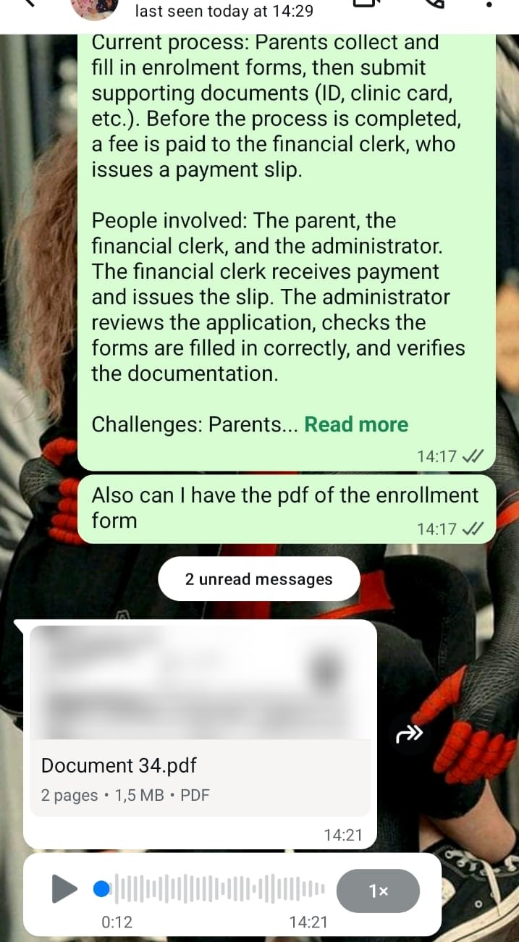

APPENDIX E : ADDITIONAL CURRENT-PROCESS EVIDENCE
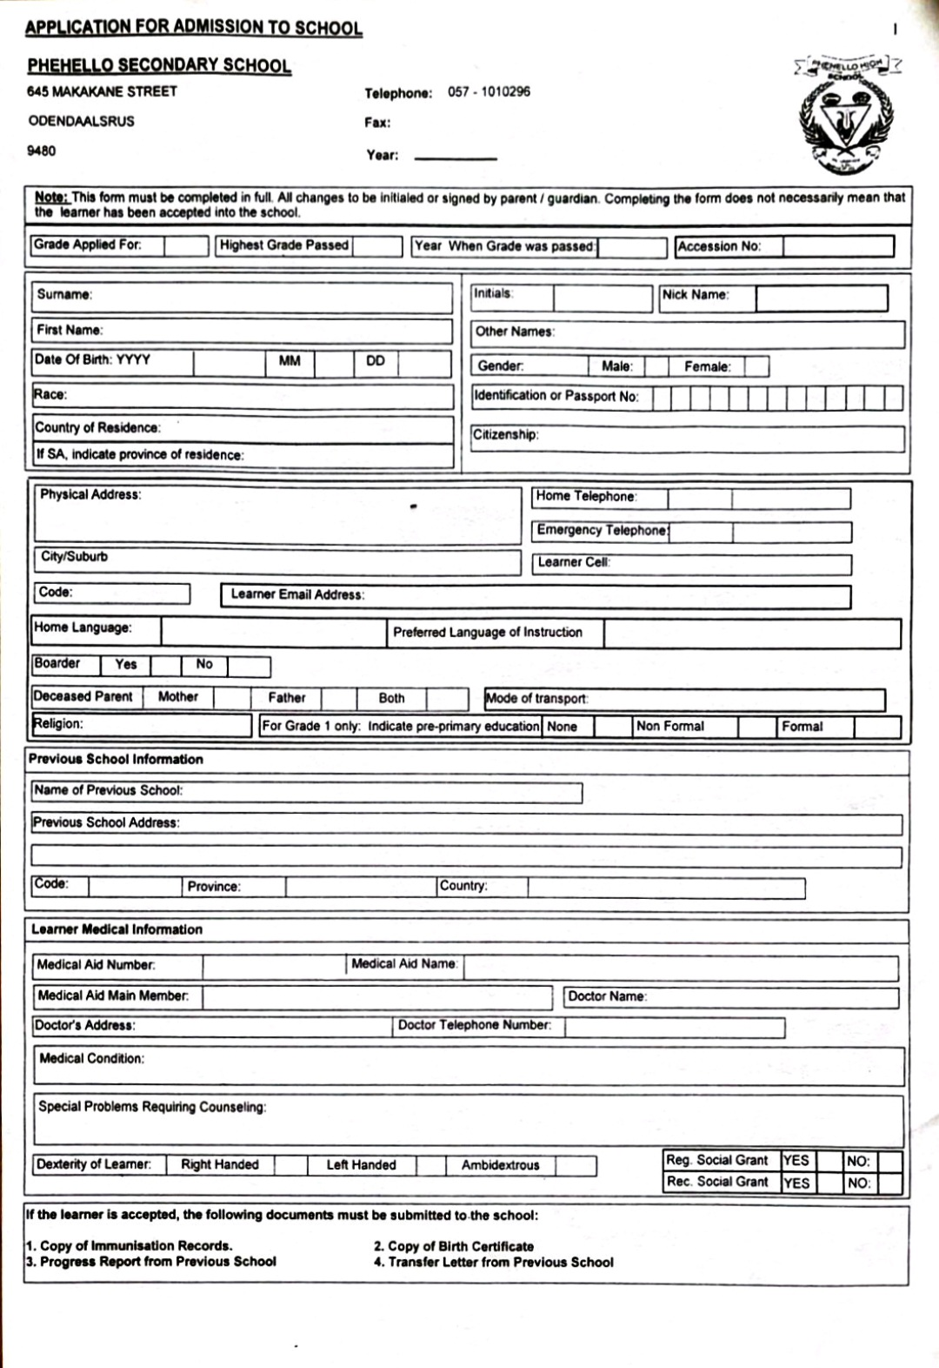

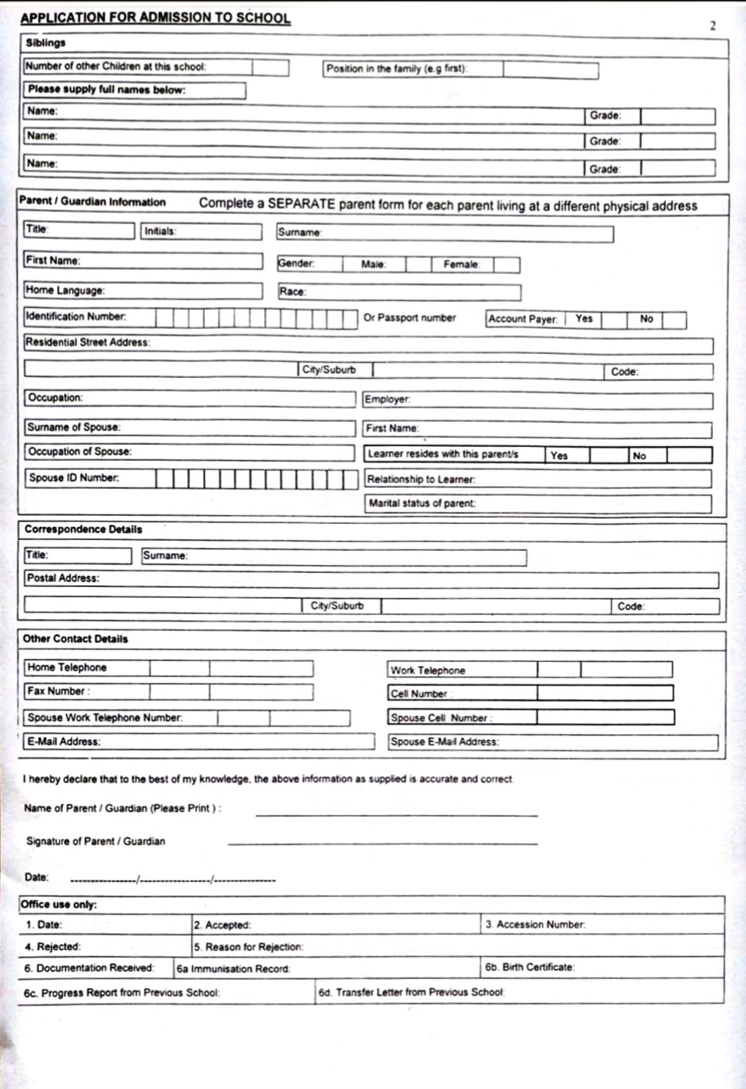
PROJECT SETUP EVIDENCE

GITHUB REPOSITORY SETUP

Repository Name: WIL-Project-2026
URL: https://github.com/Katleho-19/WIL-Project-2026
Visibility: Private
Primary Branch: main

Repository README & Overview
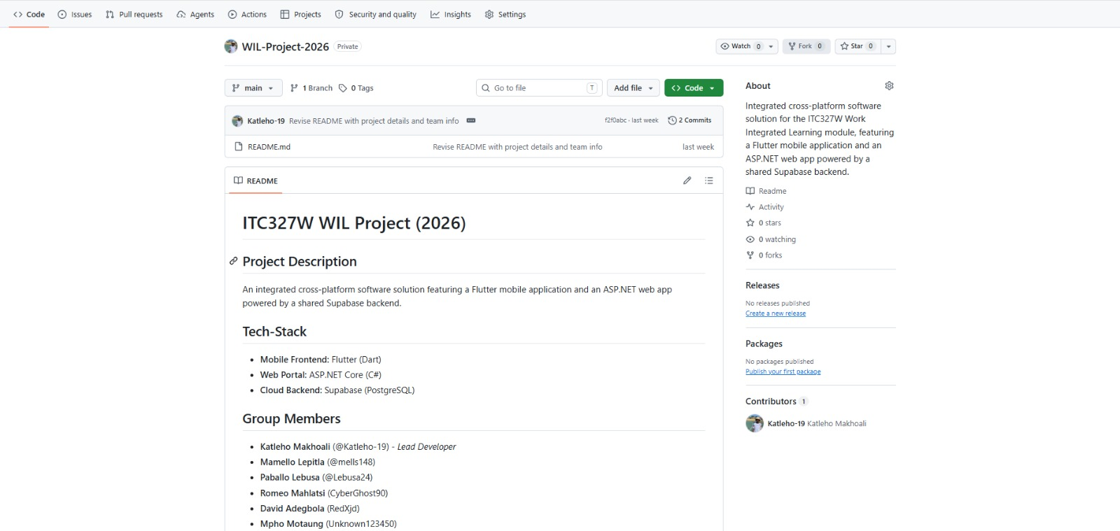

Team Collaborators & Access Control
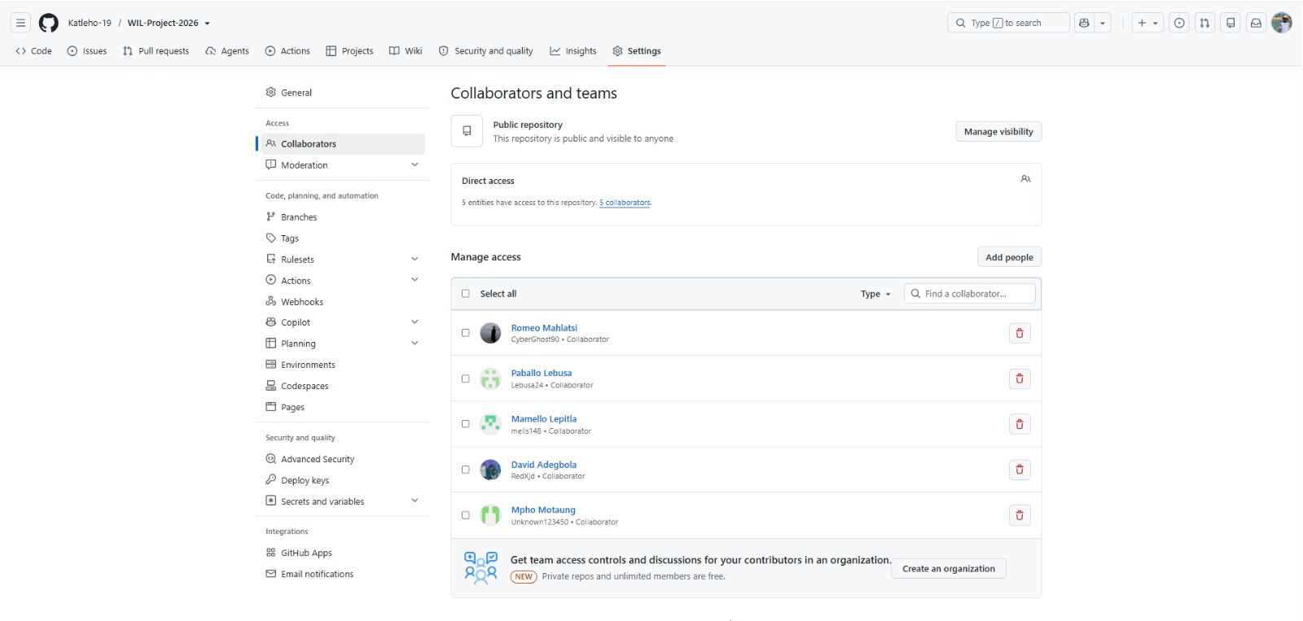

SUPABASE BACKEND SETUP

Supabase Project Overview

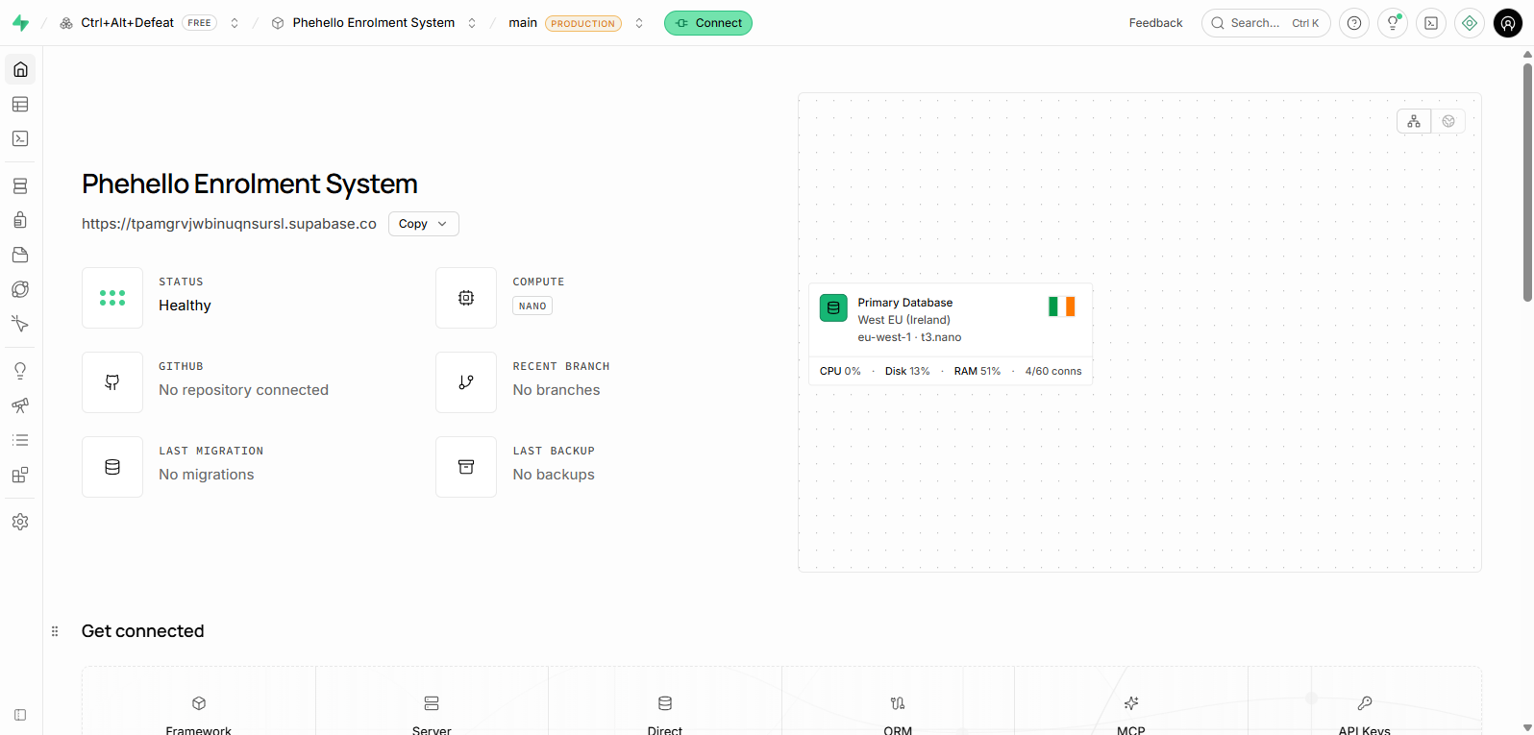

Database Schema/Table editor
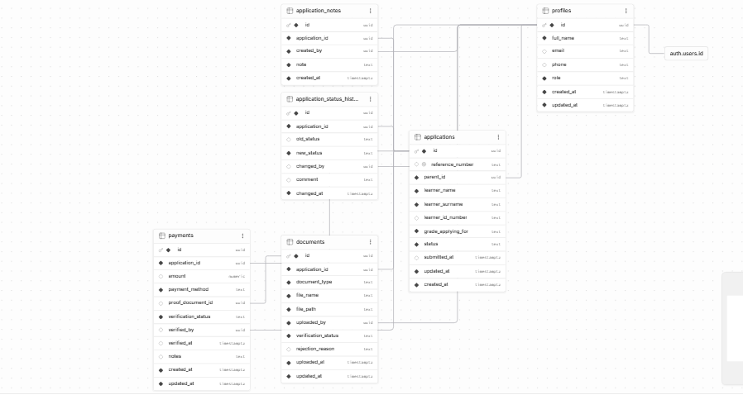

Storage Buckets Setup
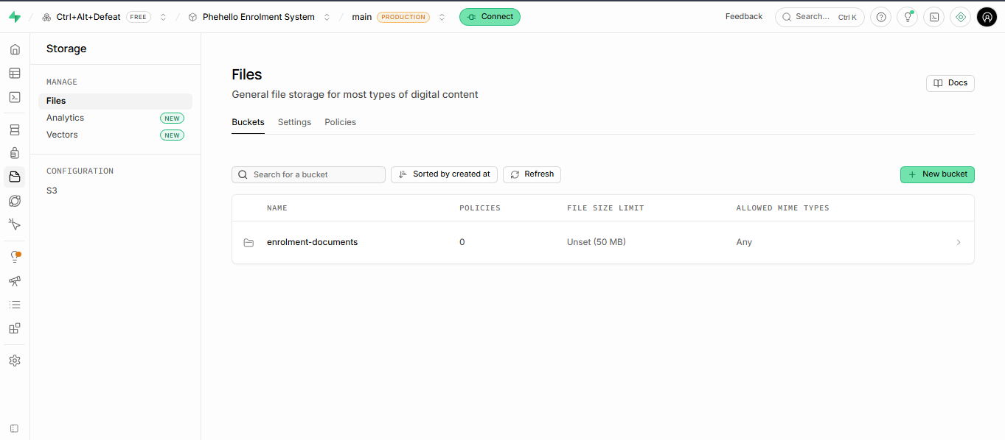

PART C: UNIT 2 FEASIBILITY AND RISK ANALYSIS

Review of the Current Project
Question | Group response
What is the main problem being addressed? | Enrolment at Phehello Secondary relies entirely on paper forms and an in-person payment step, causing lost paperwork, slow processing, no status tracking, and repeated trips to the school when documentation is incorrect.
What are the main Flutter functions? | Register/sign in, submit an enrolment application, upload documents and proof of payment, view application/payment status.
What are the main ASP.NET functions? | Financial Clerk verifies payment; Administrator views, approves/rejects, leaves notes, messages parents, sends reminders, generates confirmation letters, views application counts.
What information will Supabase manage? | Parent/learner accounts, enrolment applications, uploaded documents, proof of payment, application status, and each learner's unique student number.
Which functions appear most difficult? | Coordinating payment verification (Financial Clerk) with application approval (Administrator) as two separate steps on one shared record.
Which functions require skills the group still needs to develop? | The group has prior experience with each technology individually but has not previously implemented this complete Flutter-ASP.NET-Supabase workflow together.
Which functions may require more time than is available? | The four Should Have functions (detailed status view, notes, reminders, running count) are the first candidates to simplify or postpone if time is tight.

1. Technical Feasibility
Question | Group finding
Does the group have the required Flutter skills? | Yes - the group has used Flutter since second-year, second semester, with prior project experience.
Does the group have the required ASP.NET skills? | Yes - the group built an ASP.NET project last semester.
Can the group work with Supabase? | Yes - the group has used Supabase since the first semester of this year; the project's schema and storage buckets are already set up.
Can Flutter and ASP.NET connect to the same Supabase backend? | Yes - Supabase serves both applications through its REST/Auth/Storage APIs.
Are suitable development computers available? | Yes - all members have personal laptops.
Are suitable test devices available? | Yes - all members have Android smartphones.
Is reliable internet access available? | Internet access is available to all group members, although reliability varies by location; this is managed by scheduling development sessions around confirmed connectivity.
Which technical skills still need to be learned? | None of the three technologies individually - the untested part is combining all three for this specific enrolment-and-payment workflow.
Which functions may be too technically difficult? | None identified at Must Have priority; the integration between Flutter, ASP.NET and Supabase for payment verification is the most complex part and will be tested early.

Technical Feasibility Decision: Feasible. The group has direct experience with all three technologies and has already begun backend setup. Testing the full three-way integration early in Unit 3 is recommended as good practice, not because a skill is missing.

2. Operational Feasibility
Question | Group finding
Will the prototype address the stakeholder's problem? | Yes - it replaces the in-person, paper-and-payment-slip process with online submission, payment proof upload, and digital review.
Who will use the mobile application? | Parents/guardians - particularly young or working parents, per the confirmed interview findings.
Who will use the web application? | Financial Clerk (payment verification) and Administrator (application review and approval).
Do the intended users have suitable devices? | Assumed yes for the prototype/demonstration; a real deployment would need to confirm this for all parents.
Do users have suitable internet access? | Assumed yes for the prototype/demonstration; noted as a limitation for a real deployment rather than a blocker for this prototype.
Will the proposed solution fit the organisation's current activities? | Yes - it digitises the existing enrolment activity rather than replacing broader school administration.
Will users require guidance or training? | Minimal - the Financial Clerk and Administrator dashboards are scoped to their existing responsibilities.
Are any proposed functions unsuitable for the intended users? | No - the proposed functions match what parents and staff already do in the current process, just digitised.

Operational Feasibility Decision: Feasible. The solution was designed around the actual confirmed process and the two real staff roles involved, not assumptions.

3. Economic Feasibility
Resource | Available? | Action required
Internet access or data | Yes, variable by member | Schedule development sessions around reliable connectivity
Transport to the stakeholder | Yes | Not regularly required - stakeholder meetings are conducted via Microsoft Teams/WhatsApp
Development computers | Yes | None - all members have personal laptops
Test devices | Yes | None - all members have Android smartphones
Required software | Yes (free tiers) | Monitor Supabase free-tier storage limits as document/payment uploads are added
Supabase resources | Yes - project, schema and storage already set up | Monitor usage as tables and storage buckets grow
Presentation resources | Yes | None - existing lecture/presentation venue and equipment
Other project resources | None identified | N/A

Economic Feasibility Decision: Feasible. All resources needed are already in place at no cost.

4. Schedule Feasibility
Question | Group finding
Is enough time available for system design? | Yes, if design begins immediately after Assessment 1 feedback is received.
Is enough time available for Flutter development? | Yes, for the Must Have functions (register/sign in, submit application, upload documents and proof of payment, view status).
Is enough time available for ASP.NET development? | Yes, for the Must Have functions (view applications, verify payment, approve/reject/request corrections).
Is enough time available for Supabase integration? | Yes, provided the three-way integration is tested early rather than left until the end.
Is enough time available for testing and corrections? | Limited - a dedicated testing period needs to be reserved in the Microsoft Project schedule rather than testing only at the end.
Is enough time available for stakeholder feedback? | Yes - the stakeholder has shown consistent availability (20 Aug scoping meeting, 24 Aug formal interview, same-day confirmation).
Are too many functions currently included? | No - the confirmed Must Have functions (11 of 14 FRs) are realistic for one semester.
Which functions may need to be simplified, postponed or removed? | The four Should Have functions (detailed status view, administrator notes, deadline reminders, running application count) are the first candidates if the schedule tightens.

Schedule Feasibility Decision: Feasible with changes. Reserve an explicit testing period and an early Flutter–Supabase–ASP.NET integration test in the Microsoft Project schedule and treat the four Should Have requirements as the first candidates to simplify or postpone if the schedule tightens.

5. Legal Feasibility
Question | Group finding
Will the prototype collect personal information? | The design allows for learner/parent information and documents, but the prototype will be tested with mock data only (NFR3), not real learner records.
Is all the information necessary? | Yes - the fields requested match what the current paper enrolment form already requires; no additional information is collected.
Who should be allowed to access the information? | Only authorised staff (NFR1): the Financial Clerk sees payment information; the Administrator sees full applications; parents can only view their own application.
Will test data be used during development? | Yes - the prototype will use mock/test learner and parent information, not real learner records, per NFR3.
How will passwords and private keys be protected? | Supabase service keys and credentials are intended to be kept out of GitHub, using environment variables/local configuration only.
Does the project involve confidential stakeholder information? | Only the stakeholder's own contact details for coordination purposes, which are not published in project documentation or GitHub.
Is private stakeholder information being kept out of GitHub? | Yes, per the group's stated rule.
Is the GitHub repository's current visibility appropriate? | The repository (WIL-Project-2026) was initially created as Public, which was identified as a security and legal risk because configuration files or credentials could accidentally be exposed. The repository has since been changed to Private, with all group members given access. This is the appropriate visibility for the project.

Legal Feasibility Decision: Feasible. The repository visibility issue identified during the feasibility review has been addressed by changing the repository from Public to Private. The group will also continue to ensure that API keys , .env files, Supabase service-role keys and other sensitive credentials are not committed to GitHub.

6. Ethical Feasibility
Question | Group finding
Does the stakeholder understand the purpose of the project? | Yes. The project was explained to the Principal during the initial scoping meeting, where she agreed to act as the group’s official stakeholder. The formal requirements interview was subsequently conducted with Zukiswa Khondlo, the Principal’s delegated representative.
Is unnecessary personal information being collected? | No - only information already required by the existing paper process and confirmed enrolment form.
Could the proposed solution negatively affect intended users? | A parent without smartphone/data access could be disadvantaged in a real deployment; acknowledged as a limitation of a semester prototype, not something this project needs to solve.
Is information being used only for its intended purpose? | Yes. The system is designed only for learner enrolment and application processing. During development and testing, mock data will be used instead of real learner records.
Does the prototype accurately reflect stakeholder needs? | Yes - requirements were revised directly from the confirmed 24 August interview findings, not assumptions.
Are users being treated fairly and responsibly? | Yes. The system is used to reduce unnecessary travel and queues while maintaining separate access permissions for parents, the Financial Clerk and the Administrator. A real deployment would also need to consider parents who do not have reliable smartphone or internet access.

Ethical Feasibility Decision: Feasible.

Feasibility Summary
Feasibility Area | Decision | Main Reason | Action Required
Technical | Feasible | The team already has hands-on experience with Flutter, ASP.NET and Supabase from prior coursework, and the Supabase backend (project, schema and storage) has already been created and configured. The main outstanding risk is untested three-way integration between the mobile app, web app and shared backend. | Test the full 3-way integration early in Unit 3
Operational | Feasible | The proposed system was designed directly around the process and roles confirmed in the 24 August stakeholder interview - including the Financial Clerk and Administrator roles and the payment-proof step - rather than assumptions, so it should fit how the school actually works. | None
Economic | Feasible | Flutter, ASP.NET and Supabase are all free to use at the project's current scale, and the group already has the laptops and internet access needed to complete the prototype. No paid services or infrastructure are required. | Monitor Supabase free-tier limits
Schedule | Feasible with changes | The confirmed scope grew from the original draft to 14 functional requirements after the stakeholder interview, increasing the amount of development and testing work needed within the remaining semester weeks. | Reserve a dedicated testing period; simplify Should Have items first if needed
Legal | Feasible | The GitHub repository was identified as Public during the risk assessment, which could have exposed configuration files or credentials; this has since been corrected. | Completed - repository is now set to Private. Continue to audit commit history for any accidentally committed secrets.
Ethical | Feasible | The prototype only collects information the stakeholder confirmed is actually used in the enrolment process, and testing will use fictional/test data rather than real learner or financial records. | None

Overall Feasibility Decision
The project is feasible with changes.
The proposed project is feasible with changes. The main strengths are that it addresses a real, stakeholder-confirmed problem, the group already has hands-on experience with all three required technologies, and Supabase setup is already underway. The main actions required before proceeding further are: (1) reserve dedicated testing time and test the three-way integration early in Unit 3, and (2) switch the GitHub repository to Private and audit it for accidentally committed credentials. Neither action requires removing any confirmed stakeholder requirement.

PROJECT RISK REGISTER
Risk Rating Scale
Likelihood: 1= Low 2=Medium 3=High Impact: 1=Low 2=Medium 3=High
Risk Score: Likelihood * Impact
Risk Level: 1-2=Low 3-4=Medium 6-9=High
ID | Risk statement | Category | L | I | Score | Level | Mitigation | Contingency | Owner | Status
R01 | Although each technology is individually familiar, Flutter, ASP.NET and Supabase have not yet been connected together for this specific enrolment/payment workflow. | Technical | 2 | 2 | 4 | Medium | Build and test a small end-to-end integration example (submit → store → display → status update) as the first Unit 3 task. | Isolate and simplify the affected integration point while other development continues. | Mamello Lepitla | Open
R02 | The GitHub repository is currently Public, which could expose configuration files or credentials if accidentally committed. | Data and security | 2 | 3 | 6 | Medium | Switch the repository to Private immediately; audit commit history now for any committed secrets. | Rotate any exposed Supabase keys immediately and remove the exposed file from history. | Katleho Makhoali | Resolved -repository switched to private; continue monitoring repository history for exposed credentials
R03 | The confirmed scope grew after the interview (14 functional requirements vs. the original draft), which may leave insufficient time for testing. | Schedule | 2 | 3 | 6 | Medium | Reserve a dedicated testing period in the Microsoft Project schedule; treat Should Have requirements as first to simplify if needed. | Postpone or simplify Should Have functions (status view detail, notes, reminders, running count) to protect the Must Have core. | Paballo Lebusa | Open
R04 | Incorrectly implemented role separation could let the Financial Clerk see more than payment information or let the Administrator bypass the Clerk's verification. | Non-functional/security | 2 | 3 | 6 | Medium | Implement and test role-based access (NFR6) as part of initial Supabase/ASP.NET setup, not as an afterthought. | Restrict access immediately and review the access-control implementation. | Lerato Mahlatsi | Open
R05 | There is a risk that changes to the school’s required enrolment documents could occur after the requirements have been confirmed, resulting in changes to the documents-upload function. | Requirements | 1 | 2 | 2 | Low | Confirm any future changes to the school’s enrolment form with the stakeholder before implementing or finalising the document-upload function. | Update the FR3 and the document-upload function through the requirements change process if the school introduces additional or different document requirements. | Mamello Lepitla | Open
R06 | A group member may not complete assigned tasks on time, delaying dependent activities. | Team | 2 | 2 | 4 | Medium | Assign clear individual tasks with due dates in the Project Progress Tracker; review weekly. | Reassign urgent tasks and record the contribution concern in the tracker. | Katleho Makhoali | Open
R07 | Limited testing of the Flutter–Supabase–ASP.NET integration could let defects (e.g. payment status not syncing) go unnoticed until late in the project. | Quality | 2 | 3 | 6 | Medium | Test each integration point as soon as it is built, not only during a final testing phase. | Roll back to the last working version and fix the specific integration point. | Lerato Mahlatsi | Open
R08 | Poor or inconsistent communication within the group could cause misunderstandings about task ownership. | Team | 2 | 2 | 4 | Medium | Hold a short weekly check-in; record decisions in the Project Progress Tracker. | Escalate to the module facilitator if disagreements cannot be resolved within the group. | Mamello Lepitla | Open
R09 | Unreliable internet access for one or more members could disrupt development sessions or stakeholder calls. | Resources | 2 | 1 | 2 | Low | Schedule key sessions at times/locations with confirmed reliable connectivity. | Reschedule the affected session and share notes with absent members. | David Adegbola | Open
R10 | The group could be tempted to add functions the stakeholder never requested (e.g. automated document verification), increasing scope beyond what's achievable. | Scope | 1 | 2 | 2 | Low | Check any new function idea against the confirmed requirements list before starting it. | Remove or postpone the added function if it threatens Must Have delivery. | Mpho Motaung | Open
R11 | The Principal may become less available for future confirmations now that the main interview is complete. | Stakeholder | 1 | 2 | 2 | Low | Confirm any future changes in writing (WhatsApp/email) rather than relying only on live meetings. | Use previously confirmed findings as the baseline and request written follow-up. | David Adegbola | Open

Three Highest Risks
Highest risk | Why is this important? | What must the group do now?
R02 - Public GitHub repository | A credential leak is one of the few risks here that could cause real, irreversible harm (exposed Supabase keys), not just project delay. | Switch the repository to Private this week and audit commit history for secrets.
R03 - Scope grew after the interview | More confirmed requirements than originally drafted means less slack for testing if not planned for now. | Add an explicit testing period to the Microsoft Project schedule before development ramps up.
R04 - Financial Clerk / Administrator role separation | Getting this wrong exposes payment information to the wrong role or lets approvals bypass payment verification - a core part of the confirmed process. | Design and test role-based access as part of initial setup, not as a late add-on.

Review of Feasibility and Risk Findings
Finding | Does the project need to change? | What change is required?
Technical feasibility | No | None - group already has the required skills; proceed with early integration testing as planned
Operational feasibility | No | None - solution matches the confirmed real process and users
Economic feasibility | No | None - all resources already available at no cost
Schedule feasibility | Yes | Add a dedicated testing period and an early three-way integration test to the Microsoft Project schedule
Legal feasibility | Yes | Switch the GitHub repository from Public to Private; audit for committed secrets
Ethical feasibility | No | None - only necessary information is collected, using test data
High project risks (R02, R03, R04) | Yes | Repository visibility change (R02); dedicated testing period (R03); role-based access implemented and tested early (R04)

Requirements Change Log
Requirement / Item | Original assumption | Change / Status | Reason
FR3 — required documents | Draft assumed birth certificate, transfer letter and school report | Updated to documents confirmed on the school’s enrolment form: immunisation records, birth certificate, progress report from previous school, and transfer letter from previous school. | The actual Phehello Secondary School enrolment form was received after the initial requirements draft and provides the school’s confirmed document requirements.
Stakeholders table | Draft assumed one generic “admin staff” role | Split into Financial Clerk and Administrator as two distinct roles with different permissions (NFR6) | Confirmed in the interview - payment verification and application approval are handled by different staff
GitHub repository visibility | Repository created as Public | Recommended change to Private | Identified as a legal-feasibility risk (R02) -reduces exposure of credentials/config files
Microsoft Project schedule | N/A | Add a dedicated testing period and an early three-way integration test | Identified through Technical and Schedule feasibility findings and Risk R01/R03/R07

Refined Project Scope
Function / Requirement | Decision | Reason | Stakeholder informed?
FR1–FR8, FR14 (core application, payment, review) | Keep | Must Have - directly addresses the confirmed problem | Yes - confirmed 24 Aug interview
FR9–FR11, FR13 (notes, messaging, reminders, running count) | Keep (Should Have) | Valuable stakeholder-requested features, but they are the secondary to the core enrolment , payment and application-review functions. They are the first features to simplify or postpone if the schedule becomes tight. | Yes - explicitly requested during the stakeholder requirements interview.
FR12 (confirmation letters) | Keep | Explicitly requested; matches existing student-number fraud-prevention practice | Yes
NFR6 (Financial Clerk / Administrator permission split) | Keep | Matches the two distinct staff roles confirmed in the interview | N/A - internal design decision
Automated document verification / OCR | Remove | Never requested; adds technical complexity outside available time | N/A - was never part of the scope
Full online payment processing | Remove (unchanged from Unit 1) | Only proof-of-payment upload and verification was requested, not payment processing itself | Yes - confirmed as an original exclusion

Stakeholder Confirmation of Important Changes
Item | Details
Date of communication or meeting | 24 August 2026 (during and immediately after the stakeholder needs-assessment interview)
Changes discussed | Confirmed the payment/proof-of-payment step, the Financial Clerk role, and the documents actually required (ID, clinic card, and others per the school's enrolment form)
Reason for the changes | These reflect the stakeholder's confirmed current process, not the group's original Unit 1 assumptions
Stakeholder comments | The Secretary, Zukiswa Khondlo confirmed the findings summary as accurate (see Appendix D) on behalf of the school.
Changes accepted? | Yes - confirmed by Zukiswa Khondlo
Evidence available | See Appendix B (interview record) and Appendix D (confirmation of findings)
Outstanding item | The repository-visibility change (Public → Private) and the added testing period are internal project-management decisions arising from the feasibility study, not changes to stakeholder-facing functions, so no separate stakeholder confirmation is required for them

